1. To compute average marks of ‘n’ students (Name, Roll_No, Test Marks) and
search a particular record based on ‘Roll_No’.

Code :-

#include <stdio.h>
int main()
{
float marks[100]={0};
int roll_no[100]={0};
char name[100][20]={0};
int i,n;
printf("\nEnter the details of students: ");
scanf("%d", &n);
for(int i=0;i<n;i++){
printf("Name : ");
scanf("%s",name[i]);
printf("Roll No: ");
scanf("%d",&roll_no[i]);
printf("Test marks : ");
scanf("%f",&marks[i]);
}

float sum = 0;
for(int i=0;i<n;i++){
sum += marks[i];
}

float average = sum / n;
printf("\nAverage marks of %d students is: %.2f\n", n, average);

int search_roll_num;
printf("\nEnter roll no of student to search: ");
scanf("Search Roll number:- %d", &search_roll_num);

for(i = 0; i < n; i++){
if (roll_no[i] == search_roll_num){
printf("\nStudent Details:\n");
printf("Name: %s\n", name[i]);
printf("Roll No: %d\n", roll_no[i]);
printf("Test Marks: %.2f\n",marks[i]);
break;
}
}

if(i == n){
printf("\nStudent record not found!\n");
}
return 0;
}
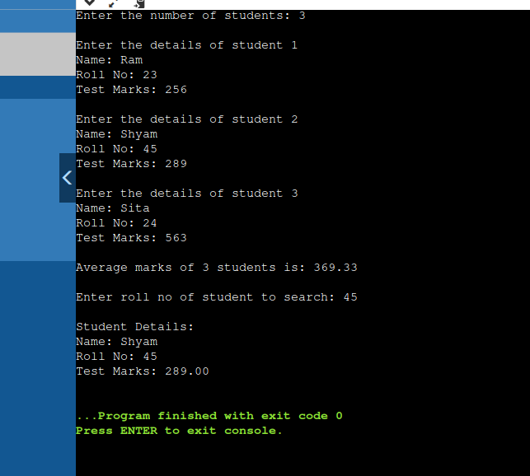

2. To Check Whether a Character is Vowel or Consonant

Code:-
#include <stdio.h>
int main()
{
char ch;

printf("Input any alphabet : ");
scanf("%c", &ch);

if(ch=='a' || ch=='e' || ch=='i' || ch=='o' || ch=='u' || ch=='A' || ch=='E' || ch=='I' || ch=='O' || ch=='U')
{
printf("The alphabet is a vowel.\n");
}

else
{
printf("The alphabet is a consonant.\n");
}

return 0;
}
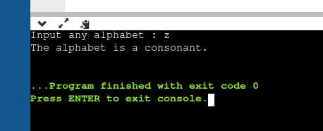

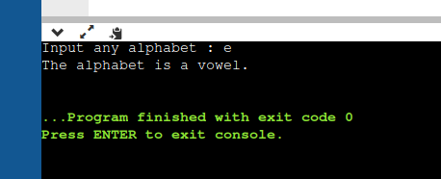

3. To Find Largest Number Among Three Numbers

Code:-

#include <stdio.h>

int main() {

int num1, num2, num3;

printf("Enter first number: ");
scanf("%d", &num1);
printf("Enter second number: ");
scanf("%d", &num2);
printf("Enter third number: ");
scanf("%d", &num3);

if (num1 >= num2 && num1 >= num3)
printf("%d is the largest number", num1);

if (num2 >= num1 && num2 >= num3)
printf("%d is the largest number", num2);

if (num3 >= num1 && num3 >= num2)
printf("%d is the largest number", num3);

return 0;
}

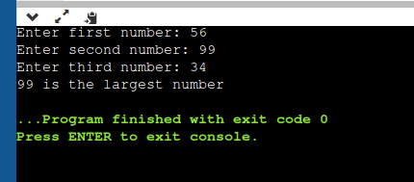

4. To Calculate Sum of Natural Numbers

Code:-

#include <stdio.h>
int main()
{
int i,n,sum=0;

printf("Input:- ");
scanf("%d",&n);

printf("\nThe first %d natural numbers are:- ",n);
for(i=1;i<=n;i++)
{
printf("%d ",i);
sum+=i;
}
printf("\nThe Sum of natural numbers: %d \n",sum);

return 0;

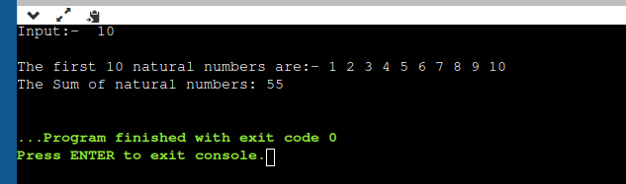
}

5. To Make a Simple Calculator

code:-

#include <stdio.h>

int main() {

char op;
int first, second;
printf("Enter an operator (+, -, *, /): ");
scanf("%c", &op);

printf("Enter two operands: ");
scanf("%d %d", &first, &second);

switch (op) {
case '+':
printf("%d + %d = %d", first, second, first + second);
break;
case '-':
printf("%d - %d = %d", first, second, first - second);
break;
case '*':
printf("%d * %d = %d", first, second, first * second);
break;
case '/':
printf("%d / %d = %d", first, second, first / second);
break;

default:
printf("Error! operator is not correct");
}

return 0;
}

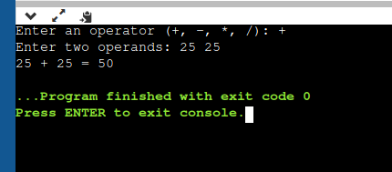

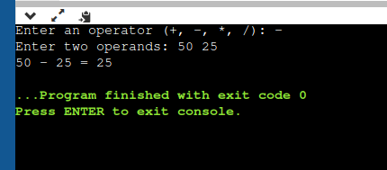

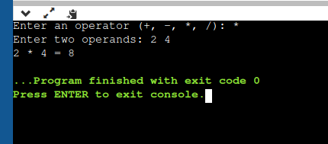

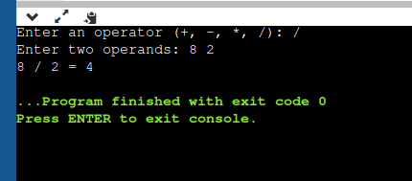

6. To Generate Multiplication Table

Code:-

#include <stdio.h>
int main() {

int n;
printf("Enter an integer: ");
scanf("%d", &n);

for (int i = 1; i <= 10; ++i) {
printf("%d x %d = %d \n", n, i, n * i);
}

return 0;

}

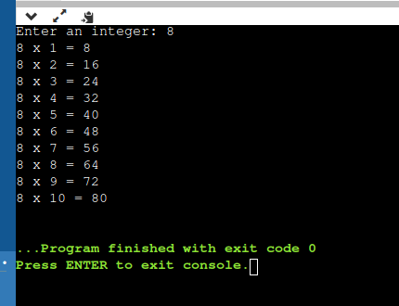

7. To Check Armstrong Number

Code:-
#include <stdio.h>

int main()
{
int m, p, sum = 0;
printf("Input:-");
scanf("%d", &m);

int t = m;
while( m != 0)
{
p = m % 10;
sum = sum + (p*p*p);
m = m / 10;
}
if(sum == t){
printf("Armstrong Number:- %d \n", t);
}
else{
printf("Not an Armstrong Number :-%d", t);
}
return 0;
}

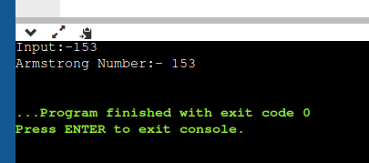

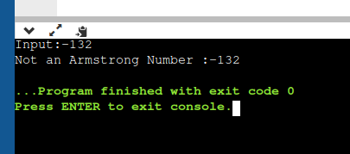

8. To Reverse a Number

Code:-

int rem, rev = 0,num;
printf("INPUT:-");
scanf("%d", &num);

while(num>0)
{
rem = num % 10;
rev = rev * 10 + rem;
num = num / 10;
}

printf("Reverse number:- %d",rev);

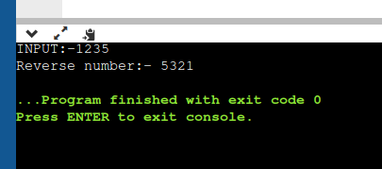

9. To Check Whether a Number is a Palindrome or Not

Code:-

#include <stdio.h>

int main()
{
int rem, rev = 0,num, t;
printf("INPUT:-");
scanf("%d", &num);

t = num;

while(t>0)
{
rem = t % 10;
rev = rev * 10 + rem;
t = t / 10;
}

if( rev == num ){
printf("\n%d is Palindrome.\n", num);
}
else{
printf("%d is not Palindrome.\n", num);
}

return 0;
}
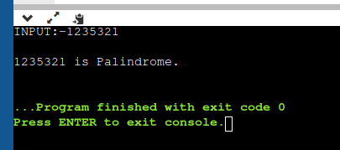

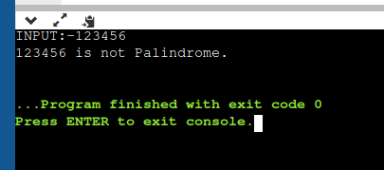

10. To Check Whether a Number is Prime or Not

Code:-

#include <stdio.h>

int main()
{
int num,i,c=0;
printf("Input a number: ");
scanf("%d",&num);

for(i=2; i<=num/2; i++)
{
if(num % i == 0)
{
c++;
}
}
if(c==0 && num!= 1){
printf("%d is a prime number.\n",num);
}
else{
printf("%d is not a prime number",num);
}
return 0;
}

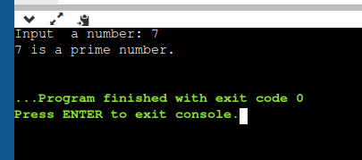

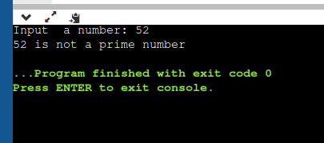

11. To Find All Factors of a Natural Number

Code:-

#include <stdio.h>

int main()
{
int i, num;

printf("Enter any number:- ");
scanf("%d", &num);

printf("All factors of %d are:- ", num);

for(i=1; i<=num; i++)
{
if(num % i == 0)
{
printf("%d, ",i);
}
}

return 0;
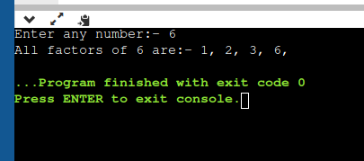
}

12. That reads N integer numbers and arrange them in ascending or descending
order using selection sort and bubble sort technique.

Code:-
#include <stdio.h>
int main()
{
int array[100], n, c, d, swap;
printf("Enter number of elements:- ");
scanf("%d", &n);

printf("Enter %d integers:- ", n);

for (c = 0; c < n; c++)
scanf("%d", &array[c]);

for (c = 0 ; c < n - 1; c++)
{
for (d = 0 ; d < n - c - 1; d++)
{
if (array[d] > array[d+1]) /* For decreasing order use '<' instead of '>' */
{
swap = array[d];
array[d] = array[d+1];
array[d+1] = swap;
}
}
}

printf("Sorted list in ascending order(Bubble Sort): ");

for (c = 0; c < n; c++)
printf("%d ", array[c]);

//Selection Sort
int position,t;
for (c = 0; c < (n - 1); c++) // finding minimum element (n-1) times
{
position = c;
for (d = c + 1; d < n; d++)
{
if (array[position] > array[d])
position = d;
}
if (position != c)
{
t = array[c];
array[c] = array[position];
array[position] = t;
}
}

printf("\nSorted list in ascending order(selection sort) : ");

for (c = 0; c < n; c++)
printf("%d ", array[c]);

return 0;
}

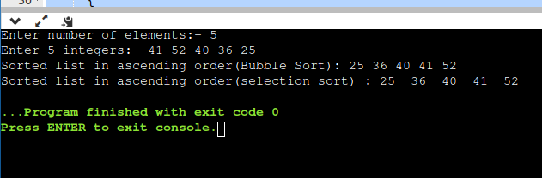

13. To compute and print Matrix multiplication.

Code:-
#include<stdio.h>
#include<stdlib.h>
int main(){
int a[10][10],b[10][10],mul[10][10],r,c,i,j,k;
printf("enter the number of row=");
scanf("%d",&r);
printf("enter the number of column=");
scanf("%d",&c);

printf("enter the first matrix element=\n");
for(i=0;i<r;i++)
{
for(j=0;j<c;j++)
{
scanf("%d",&a[i][j]);
}
}

printf("enter the second matrix element=\n");
for(i=0;i<r;i++)
{
for(j=0;j<c;j++)
{
scanf("%d",&b[i][j]);
}
}

printf("Multiply of the matrix=\n");
for(i=0;i<r;i++)
{
for(j=0;j<c;j++)
{
mul[i][j]=0;
for(k=0;k<c;k++){
mul[i][j]+=a[i][k]*b[k][j];
}
}
}
for(i=0;i<r;i++)
{
for(j=0;j<c;j++)
{
printf("%d\t",mul[i][j]);
}
printf("\n");
}
return 0;
}

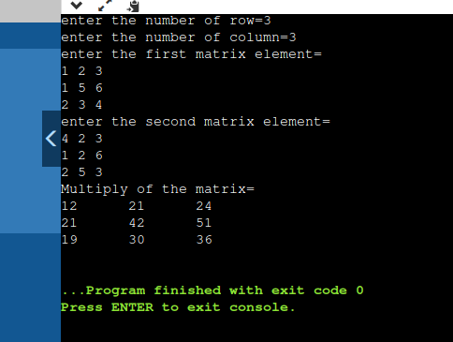

14. To search an element using Binary search and linear search techniques.

Code:-
#include<stdio.h>
int main(){
int n,x;
printf("Enter the number of elements in the array : ");
scanf("%d",&n);
printf("Binary Search : \n\n");

int a[n];
printf("Enter the array elements in sorted order : ");
for(int i=0;i<n;i++){
scanf("%d",&a[i]);
}
printf("Enter the element for binary Search : ");
scanf("%d",&x);
int l = 0, r = n-1;
while (l <= r) {
int m = l + (r - l) / 2;

// Check if x is present at mid
if (a[m] == x){
printf("The %d element is in %d index\n",x,m);
goto linear;
}

// If x greater, ignore left half
if (a[m] < x)
l = m + 1;
// If x is smaller, ignore right half
else
r = m - 1;
}
printf("The element is not in the array.\n");
linear:
printf("Linear Search : \n");
printf("Enter the array elements in sorted order : ");
for(int i=0;i<n;i++){
scanf("%d",&a[i]);
}
printf("Enter the element for binary Search : ");
scanf("%d",&x);
for(int i=0;i<n;i++){
if(a[i] == x){
printf("The element %d is in %d index.\n",a[i],i);
break;
}
}
return 0;



